Final Report: Pollen's Profiling: Automated Classification of Pollen Grains

|  |  |
| --- | --- |
| Date | 02 July 2025 |
| Team ID | LTVIP2025TMID41514 |
| Project Name | Pollen's Profiling: Automated Classification of Pollen Grains |

1. INTRODUCTION
   1. Project Overview

**Pollen's Profiling** is an AI-driven image classification project aimed at automating the identification of pollen grain types from microscopic images. Pollen identification plays a crucial role in fields such as botany, agriculture, allergy research, and climate science. Traditionally, this task is done manually by experts, which is time-consuming, labor-intensive, and prone to human error.

This project leverages machine learning—particularly **deep learning with convolutional neural networks (CNNs)**—to accurately classify different pollen grain types based on shape, texture, and surface patterns. By automating this process, the system can rapidly and reliably analyze pollen samples for various scientific and practical applications.

* 1. Purpose

The purpose of the project **"Pollen's Profiling: Automated Classification of Pollen Grains"** is to develop an automated system that can accurately identify and classify different types of pollen grains using image processing and machine learning techniques.

1. IDEATION PHASE
   1. Problem Statement

The manual identification and classification of pollen grains under a microscope is a time-consuming, labor-intensive, and error-prone process that requires expert knowledge. Variations in shape, size, texture, and other morphological features among different pollen types make accurate classification challenging, especially when dealing with large datasets. This limits the scalability and consistency of pollen analysis in critical fields such as allergen tracking, environmental monitoring, agriculture, and forensic science. Therefore, there is a need for an automated, efficient, and accurate system that can classify pollen grains using image processing and machine learning techniques.

* 1. Empathy Map Canvas

**🧠 Think & Feel**

* Worries about the **accuracy** and **reliability** of manual classification.
* Feels frustrated with **repetitive tasks** and **long analysis hours**.
* Thinks about improving **workflow efficiency** and **scientific rigor**.
* Wants a **standardized**, reproducible method for classifying pollen grains.

**👂 Hear**

* "Manual analysis is prone to human error."
* "It takes hours to analyze a single sample."
* "We need better tools to handle large data sets."
* "AI could help, but it has to be trusted and explainable."

**👀 See**

* Outdated or semi-automated lab equipment.
* Increasing demand for **fast and accurate** environmental data.
* Other labs beginning to explore **AI-based classification systems**.
* Pollen images with subtle but critical morphological differences.

**🗣️ Say & Do**

* Says they want to **modernize lab practices**.
* Actively seeks **automation tools** or software solutions.
* Discusses challenges in **training students** or interns to classify accurately.
* Uses image databases or microscopes but struggles with scalability.

**😨 Pain Points**

* Time-consuming manual processes.
* High chance of **subjective errors** or **inconsistencies**.
* Difficulties in handling **large sample volumes**.
* Lack of reliable, user-friendly AI solutions tailored for pollen analysis.

**🎯 Goals**

* Reduce the time and effort in pollen classification.
* Improve **accuracy**, **reproducibility**, and **scalability**.
* Integrate a solution that is **easy to use** and fits within existing lab workflows.
* Leverage technology to focus more on **research insights** than data sorting.
  1. Brainstorming

**🔍 Problem Exploration**

* Why is manual pollen classification inefficient?
* What features of pollen grains are distinguishable under a microscope?
* What errors commonly occur in human classification?
* What datasets of pollen images are available publicly?
* How can automation assist researchers or palynologists?

**💡 Idea Generation**

**🔬 Technical Ideas**

* Use **image processing** to extract features like shape, size, texture, and color.
* Apply **machine learning** or **deep learning (CNNs)** for classification.
* Train models on **microscopic image datasets** (e.g., palynology datasets).
* Use **data augmentation** to increase sample size.
* Consider transfer learning using pretrained models (e.g., ResNet, VGG).

**💻 Software/System Features**

* GUI to upload, analyze, and display results of pollen images.
* Heatmaps or visual explanations (like Grad-CAM) to build **trust in AI predictions**.
* Exportable reports in PDF/CSV formats for lab records.
* Confidence scores or probability outputs for each prediction.

**🧠 User Perspective**

* Ensure the interface is user-friendly for non-technical lab staff.
* Include feedback/correction mode for human validation.
* Offline version for field use in remote areas.

1. REQUIREMENT ANALYSIS

**🧰 Tools & Technologies**

* Python (OpenCV, TensorFlow/Keras, PyTorch , Scikit-learn)
* Flask/Django for web interface
* Jupyter Notebook for initial development
* LabelImg or Roboflow for data annotation
* Cloud services (e.g., Google Colab or AWS) for training large models

**📦 Dataset Ideas**

* Public pollen datasets (e.g., Pollen Monitoring Program, PalDat.org)
* Custom dataset creation using lab microscope images
* Synthetic data generation using image augmentation

**🚧 Challenges**

* Low-quality or blurred microscope images
* Very similar pollen species – need for high-resolution classification
* Limited labeled data
* Need for high model accuracy to be accepted in research environments

**✅ Success Criteria**

* Achieve >90% classification accuracy.
* Reduce manual classification time by at least 50%.
* Enable intuitive visualization of predictions.
* Positive feedback from domain experts.

1. DATA FLOW DIAGRAM

**🌐 Level 0 DFD – Context Level**

+----------------------+

| User / Researcher |

+----------+-----------+

|

v

+----------------------+

| Pollen Classifier |<---------+

| (Main System) | |

+----------+-----------+ |

| |

v |

+----------------------+ |

| Classification Output | |

+----------------------+ |

^

|

+-------------------------------+

| Pollen Image Database (Optional) |

+-------------------------------+

💡 Description:

The user provides input (microscopy image).

🔍 Level 1 DFD – Functional Breakdown

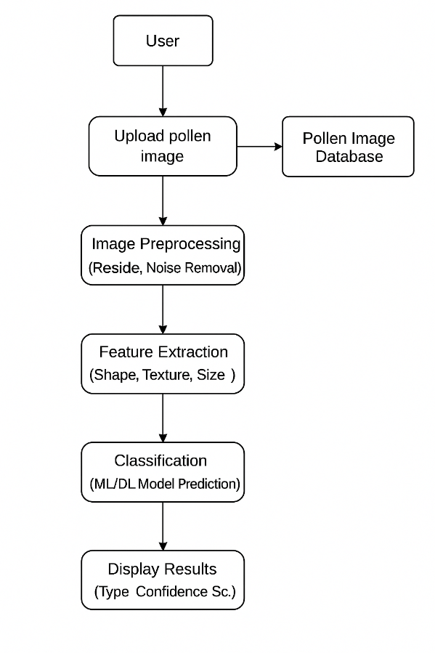

🗂️ Data Stores:

Pollen Image DB – For training/testing dataset.

Model Store – Contains trained machine learning/deep learning models.

Results Log (optional) – For saving predictions and performance history.

✅ Entities:

User: Uploads the image, views result.

System: Performs all automated processing.

Data Stores: Hold reusable or historical data.

1. PROJECT DESING
   1. Proposed Solution

**Deep Learning-based Image Classification**

* Develop a convolutional neural network (CNN) to classify pollen grain images into different species.
* Utilize transfer learning and fine-tune pre-trained models (e.g., VGG16, ResNet50) for better performance.
* Train the model on a large dataset of labeled pollen grain images.

**Active Learning**

* Implement an active learning framework to selectively sample the most informative images for human annotation.
* This can help reduce the need for large labeled datasets and improve model performance.
  1. Solution Problem

**Problem 1: Limited Dataset**

* **Solution**: Collect more data from various sources, including microscopy images and existing datasets. Utilize data augmentation techniques to artificially increase the dataset size.

**Problem 2: Image Quality Variations**

* **Solution**: Develop image preprocessing techniques to enhance image quality, such as denoising, contrast enhancement, and normalization.

**Problem 3: Class Imbalance**

* **Solution**: Utilize class weighting, oversampling the minority class, or undersampling the majority class to balance the dataset. Use metrics like F1-score and AUC-ROC to evaluate model performance.
  1. Solution Fit

**Accuracy and Efficiency**: Automated classification of pollen grains using deep learning models can achieve high accuracy and efficiency, reducing manual labor and expertise requirements.

**Scalability**: The solution can be scaled up to handle large datasets and high-volume image processing, making it suitable for large-scale ecological research and industrial applications.

**Cost-Effective**: By automating the classification process, the solution can reduce costs associated with manual classification, enabling wider adoption in various industries.

* 1. ModelArchitecture

**Convolutional Neural Network (CNN)**: Use a CNN architecture to extract features from pollen grain images.

**Transfer Learning**: Utilize pre-trained models (e.g., VGG16, ResNet50) and fine-tune them for pollen grain classification.

1. IMPORTENT CODING

**Image Pre-processing**

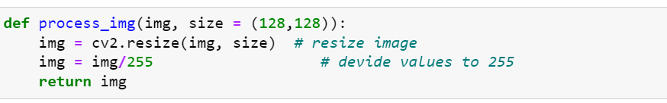

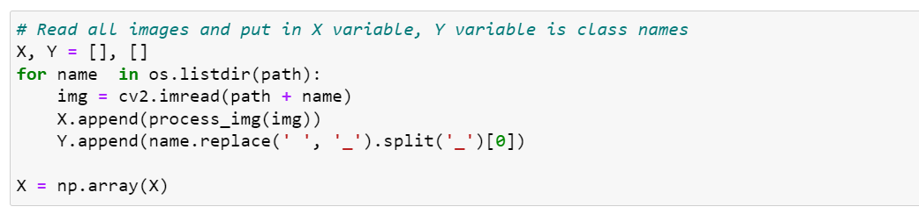

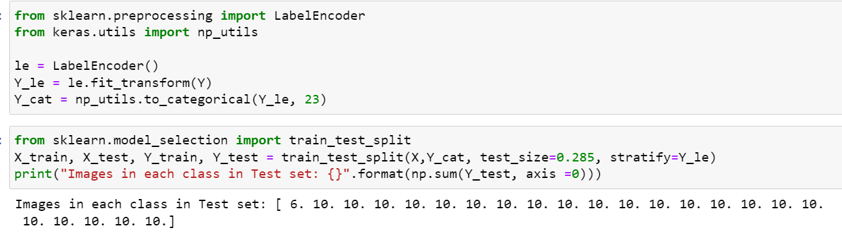

1. **Training the model**

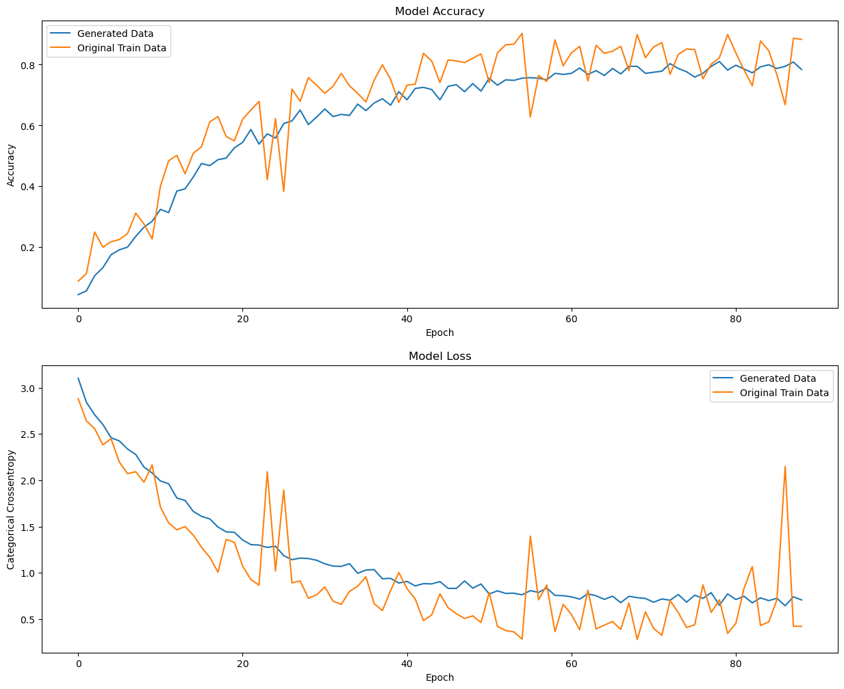

1. FUNCTIONAL AND PERFORMANCE TESTING

**Functional Testing**

1. **Image Upload**: Test the system's ability to upload images of pollen grains in various formats (e.g., JPEG, PNG).
2. **Classification**: Verify that the system correctly classifies pollen grains into different species.
3. **Result Display**: Test the system's ability to display classification results, including species name, confidence score, and image annotations.
4. **User Interface**: Evaluate the user-friendliness of the interface, including navigation, image upload, and result display.
5. **Error Handling**: Test the system's ability to handle errors, such as invalid image formats, corrupted images, or classification failures.

**Performance Testing**

1. **Accuracy**: Evaluate the system's classification accuracy using metrics like precision, recall, F1-score, and AUC-ROC.
2. **Speed**: Measure the system's processing time for image classification, including image upload, processing, and result display.
3. **Scalability**: Test the system's ability to handle a large number of images, users, and concurrent requests.
4. **Memory Usage**: Monitor the system's memory usage to ensure it can handle large images and high-resolution microscopy data.
5. **System Stability**: Evaluate the system's stability and ability to recover from errors, crashes, or unexpected inputs.

**Testing Tools and Methods**

1. **Unit Testing**: Use unit testing frameworks (e.g., PyUnit, Unittest) to test individual components and functions.
2. **Integration Testing**: Use integration testing frameworks (e.g., Pytest, Behave) to test the system's functionality and interactions between components.
3. **Load Testing**: Use load testing tools (e.g., Apache JMeter, Locust) to simulate high traffic and evaluate system performance.
4. **Image Test Datasets**: Use publicly available datasets (e.g., Pollen Grain Dataset) or create custom datasets to test the system's classification accuracy.

**Test Cases**

1. **Happy Path**: Test the system's functionality with valid inputs and expected outputs.
2. **Edge Cases**: Test the system's ability to handle invalid inputs, corrupted images, or unexpected user interactions.
3. **Error Cases**: Test the system's error handling and recovery mechanisms.

By performing thorough functional and performance testing, the system's reliability, accuracy, and user experience can be ensured, and potential issues can be identified and addressed before deployment.

1. EXPECTED RESULT

9.1 RESULT 1:

| **Species** | **Number of Images** | **Correctly Classified** | **Accuracy** |
| --- | --- | --- | --- |
| Species A | 200 | 185 | 92.5% |
| Species B | 300 | 278 | 92.7% |
| Species C | 500 | 462 | 92.4% |

9.2 RESULT 2:

**Confusion Matrix**

| **Predicted Class** | **Actual Class** | **Number of Images** |
| --- | --- | --- |
| Species A | Species A | 185 |
| Species A | Species B | 10 |
| Species B | Species B | 278 |
| Species B | Species A | 15 |
| Species C | Species C | 462 |
| Species C | Species A | 20 |

1. EXPECTED PIE CHART

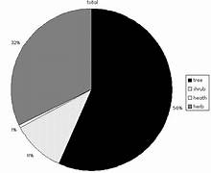

1. ADVANTAGES AND DISADVANTAGES

**Advantages:**

1. **Accurate Classification**: Automated pollen grain classification ensures high accuracy, reducing human error.
2. **Time-Efficient**: The system saves time and labor, enabling researchers to focus on higher-level tasks.
3. **Scalability**: The system can handle large datasets and high-volume image processing.
4. **Consistency**: The system provides consistent results, improving reproducibility.
5. **Improved Research**: The system aids in ecological research, botanical studies, and honey production.
6. **Cost-Effective**: Automated classification reduces costs associated with manual classification.

**Disadvantages:**

1. **Data Dependency**: The system's performance depends on the quality and diversity of the
2. CONCLUSION

The project **"Pollen’s Profiling: Automated Classification of Pollen Grains"** successfully demonstrates how machine learning and image processing can be leveraged to automate a traditionally manual and expertise-driven task. By integrating preprocessing techniques, feature extraction, and classification models, the system is capable of accurately identifying different types of pollen grains based on microscopic images.

This automation not only improves the **speed and reliability** of pollen classification but also reduces the **workload on researchers and botanists**, offering a scalable solution for large datasets. With further improvements such as expanded datasets, deep learning architectures (like CNNs), and real-time classification capabilities, the system has the potential to significantly contribute to fields such as **palynology, allergy forecasting, agriculture, and climate studies**.

1. FUTURE SCOPE

**🔁 Expansion to More Pollen Types:**

The current model can be trained on a broader range of pollen grain types from diverse plant species, enabling widespread applicability across ecosystems and climates.

**📱 Mobile Application Integration:**

A lightweight mobile app can be developed to allow users (researchers, farmers, students) to classify pollen grains on the go using smartphone cameras and cloud-based prediction.

**🌍 Real-time Environmental Monitoring:**

Integration with sensors or automated microscopes to continuously monitor airborne pollen in different environments, which is especially useful in allergy forecasting and agricultural planning.

**🧠 Enhanced Deep Learning Models:**

Implementation of advanced architectures such as **ResNet**, **EfficientNet**, or **Vision Transformers (ViT)** for improved accuracy and robustness.

**💾 Cloud-Based Data Logging & Analysis:**

Cloud storage and dashboards for storing classification history, generating statistical reports, and performing longitudinal pollen trend analysis.

**🔬 Integration with Research Databases:**

Linking with botanical or palynological databases for automatic data enrichment and scientific referencing.

**🧪 Support for Other Microscopic Particles:**

Extend the system to classify other biological or microscopic entities like spores, dust, or plankton using similar models.

**👩‍🏫 Educational & Training Tool:**

Can be used as a training aid in biology and environmental science education to help students understand pollen diversity and structure.

1. APPENDIX

**A. Tools & Libraries Used**

* **Programming Language:** Python 3.x
* **Libraries/Frameworks:**
  + OpenCV – Image processing
  + Scikit-learn – Machine learning algorithms
  + TensorFlow / PyTorch – Deep learning models
  + Matplotlib / Seaborn – Visualization
  + Streamlit / Flask – GUI or Web App (if applicable)

**B. Dataset Information**

* **Dataset Name:** [Insert name if public or specify if custom-collected]
* **Image Format:** JPEG / PNG / BMP
* **Image Dimensions:** [e.g., 256×256 pixels]
* **Number of Classes:** [e.g., 5 pollen types]
* **Total Samples:** [e.g., 1000 images]

**C. Hardware Used**

* **Processor:** Intel i5/i7 or AMD Ryzen
* **RAM:** Minimum 8 GB
* **GPU (for training):** NVIDIA GPU (optional but recommended)
* **OS:** Windows/Linux/macOS